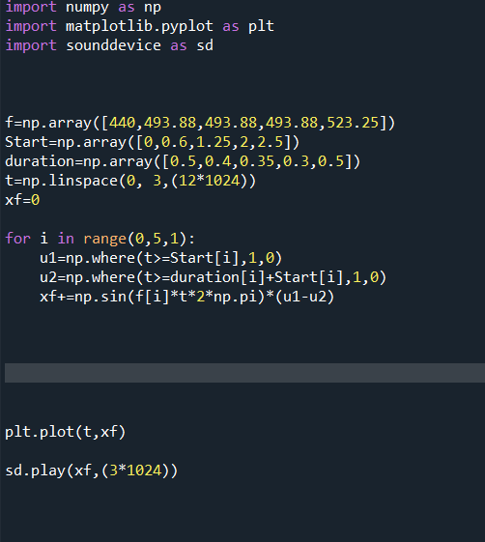

1) f is an array which stores the frequencies

Of all the signals.

2) Start is an array which stores the starting

Point of all the signals

3) duration is an array which stores the length of each signal

4) t= is our time axis

5) xf is the variable which I used to increment over in the for loop

The for loop takes each element in each of the arrays (as the same index corresponds to the same signal in each of the arrays), and then creating the necessary unit step signals using the start and duration arrays, respectively, and then incrementing each signal over the xf.

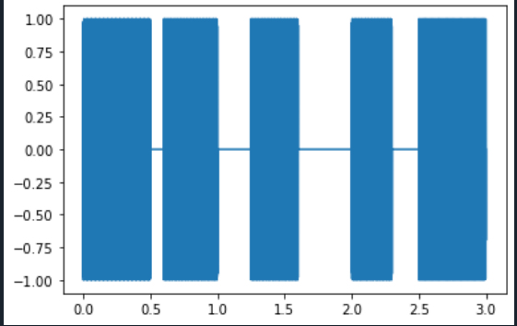

Finally plt.plot-> plots a continuous graph

Sd.play plays the sound of the graph (signal)

Mohamed Mahmoud Ismaeil, 52-5931